INFORMATION MANAGEMENT

EXERCISE 5

1. List all employees who hold the titles of "Senior Programmer" and "Multimedia Programmer".

SELECT f_name, l_name FROM employee_data WHERE title IN ('Senior Programmer', 'Multimedia Programmer');

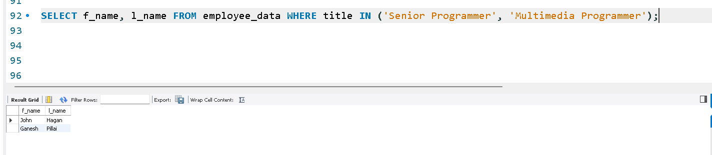

2. List all employee names with salaries for employees who draw between $70,000 and $90,000.

SELECT f_name, l_name, salary FROM employee_data WHERE salary BETWEEN 70000 AND 90000;

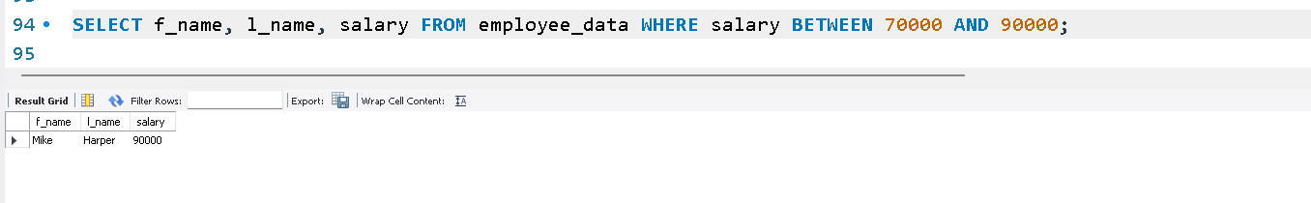

3. What will the following statement display?

SELECT f_name, l_name, title FROM employee_data WHERE title NOT IN ('Programmer', 'Senior Programmer', 'Multimedia Programmer');

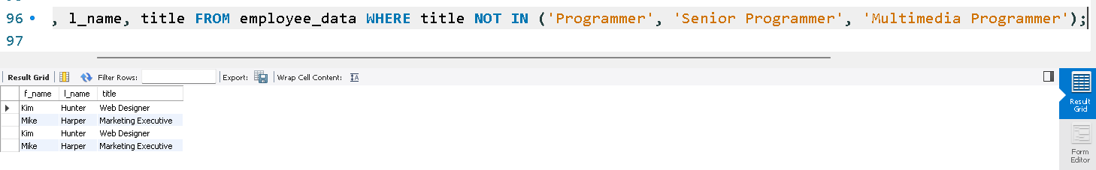

4. Here is a more complex statement that combines both BETWEEN and IN. What will it display?

SELECT f_name, l_name, title, age

FROM employee_data

WHERE title NOT IN ('Programmer', 'Senior Programmer', 'Multimedia Programmer')

AND age NOT BETWEEN 28 AND 32;

